**Practical No. 8**

AIM : Create MAC protocol simulation implementation for wireless sensor network

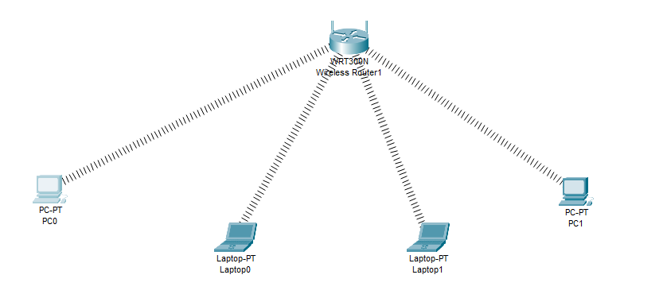

Go to router gui then go to wireless mac filter then select the options and then add the mac wanted

00:30:F2:51:EE:C0

00:90:2B:BA:90:CD

These mac will be prevented

